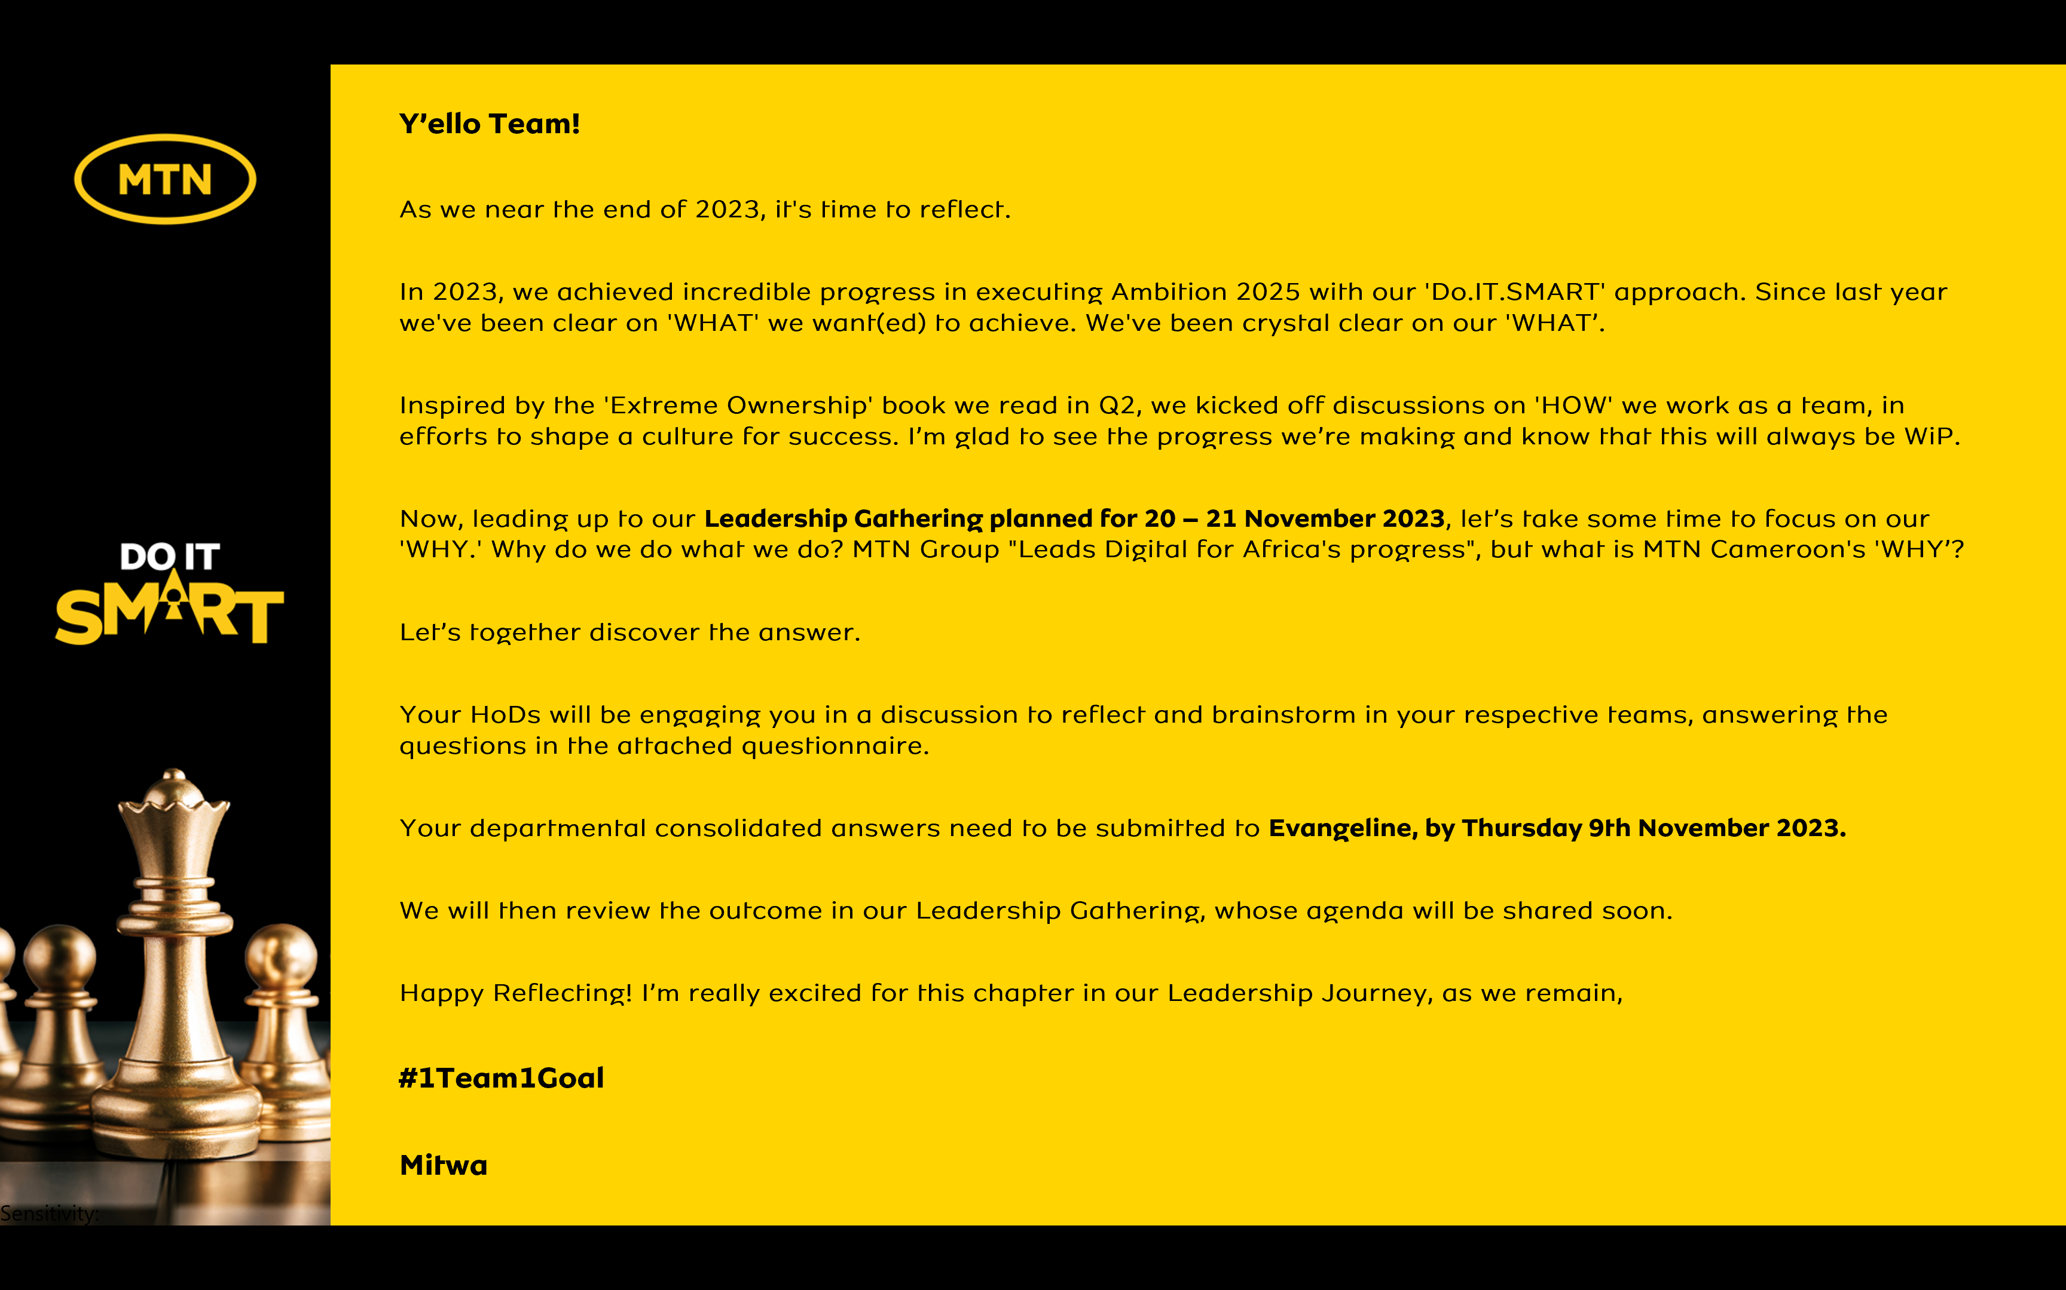
Reflecting on MTN Cameroon’s Purpose
1. When we look back as an organization, what have we always been good at? What are the 5 qualities that our organization has always had?
- People management: Taking care of our people /People engagement -business updates and fun
- Stakeholder engagement
- Working together – breaking the silos
- Diversity and Inclusiveness
- Visibility of our brand – tell our story on social media
2. Looking back into our history of working together as an organization, what is the moment when you felt truly happy and what did we achieve?
In the face of the pandemic in 2020, our company showed true resilience by both caring for our people and posting a profit – and a legacy (emotional connection, flexi work, digitalisation of ways of work)

Others:
- PSP license
- 21 days of yellow care
- Launch of the 4G and affordable 4G phones (designed by Huawei – MTN L860 phone with mifi free to boost the 4G penetration)
- Proximity to customers by opening new service centers operating 7 days a week: CARREFOUR EKIE SERVICE, CARREFOUR BONAMOUSSADI, DOUALA GRAND MALL, HILTON HOTEL
- Market invasions – launch of new product and campaigns

3. When we are collaborating as a leadership team under what circumstances do we have the most high performing energy?
- When we have the same purpose and targets
- When we have backs to the wall (garnishee case, regulatory fines)
4. What was the most challenging time in working together as a leadership team? What have we learnt from it?
- Separation of MTNC/MMC - ways of work, synergies, team spirit
- Transformation in 2018 – performance issues to fix: execution excellence, agility
5. What is the most important thing we want to accomplish as MTN Cameroon? What would we like to be known for when people talk about us in 5 years from now?
Be the first to bring 5G to Cameroon

Others
- Taking connectivity to the rural areas
- Be the number one in advanced services (nano loans, QR code, insurtech) and be the wallet of choice to the low income population
- Innovation and inclusiveness: affordability of devices and for diverse customers (disability…)
- ESG: environmental impact
- Compliance : highest index

6. There are no restrictions or limitations. The future is not known. In this moment we have the power to choose. What is our common vision going forward? What is possible when our organization puts together the best version of every individual member?
Digital and financial inclusion:

Building a connected and inclusive future through sustainable networks, innovative and affordable digital and financial solutions.

In summary,

MTN Cameroon’s Purpose in life is to

"Accelerate Cameroon's digital and financial transformation for a prosperous and equitable future"

<repeat> “ Accelerate Cameroon's digital and financial transformation for a prosperous and equitable future”

is what our life at MTN Cameroon is about.

