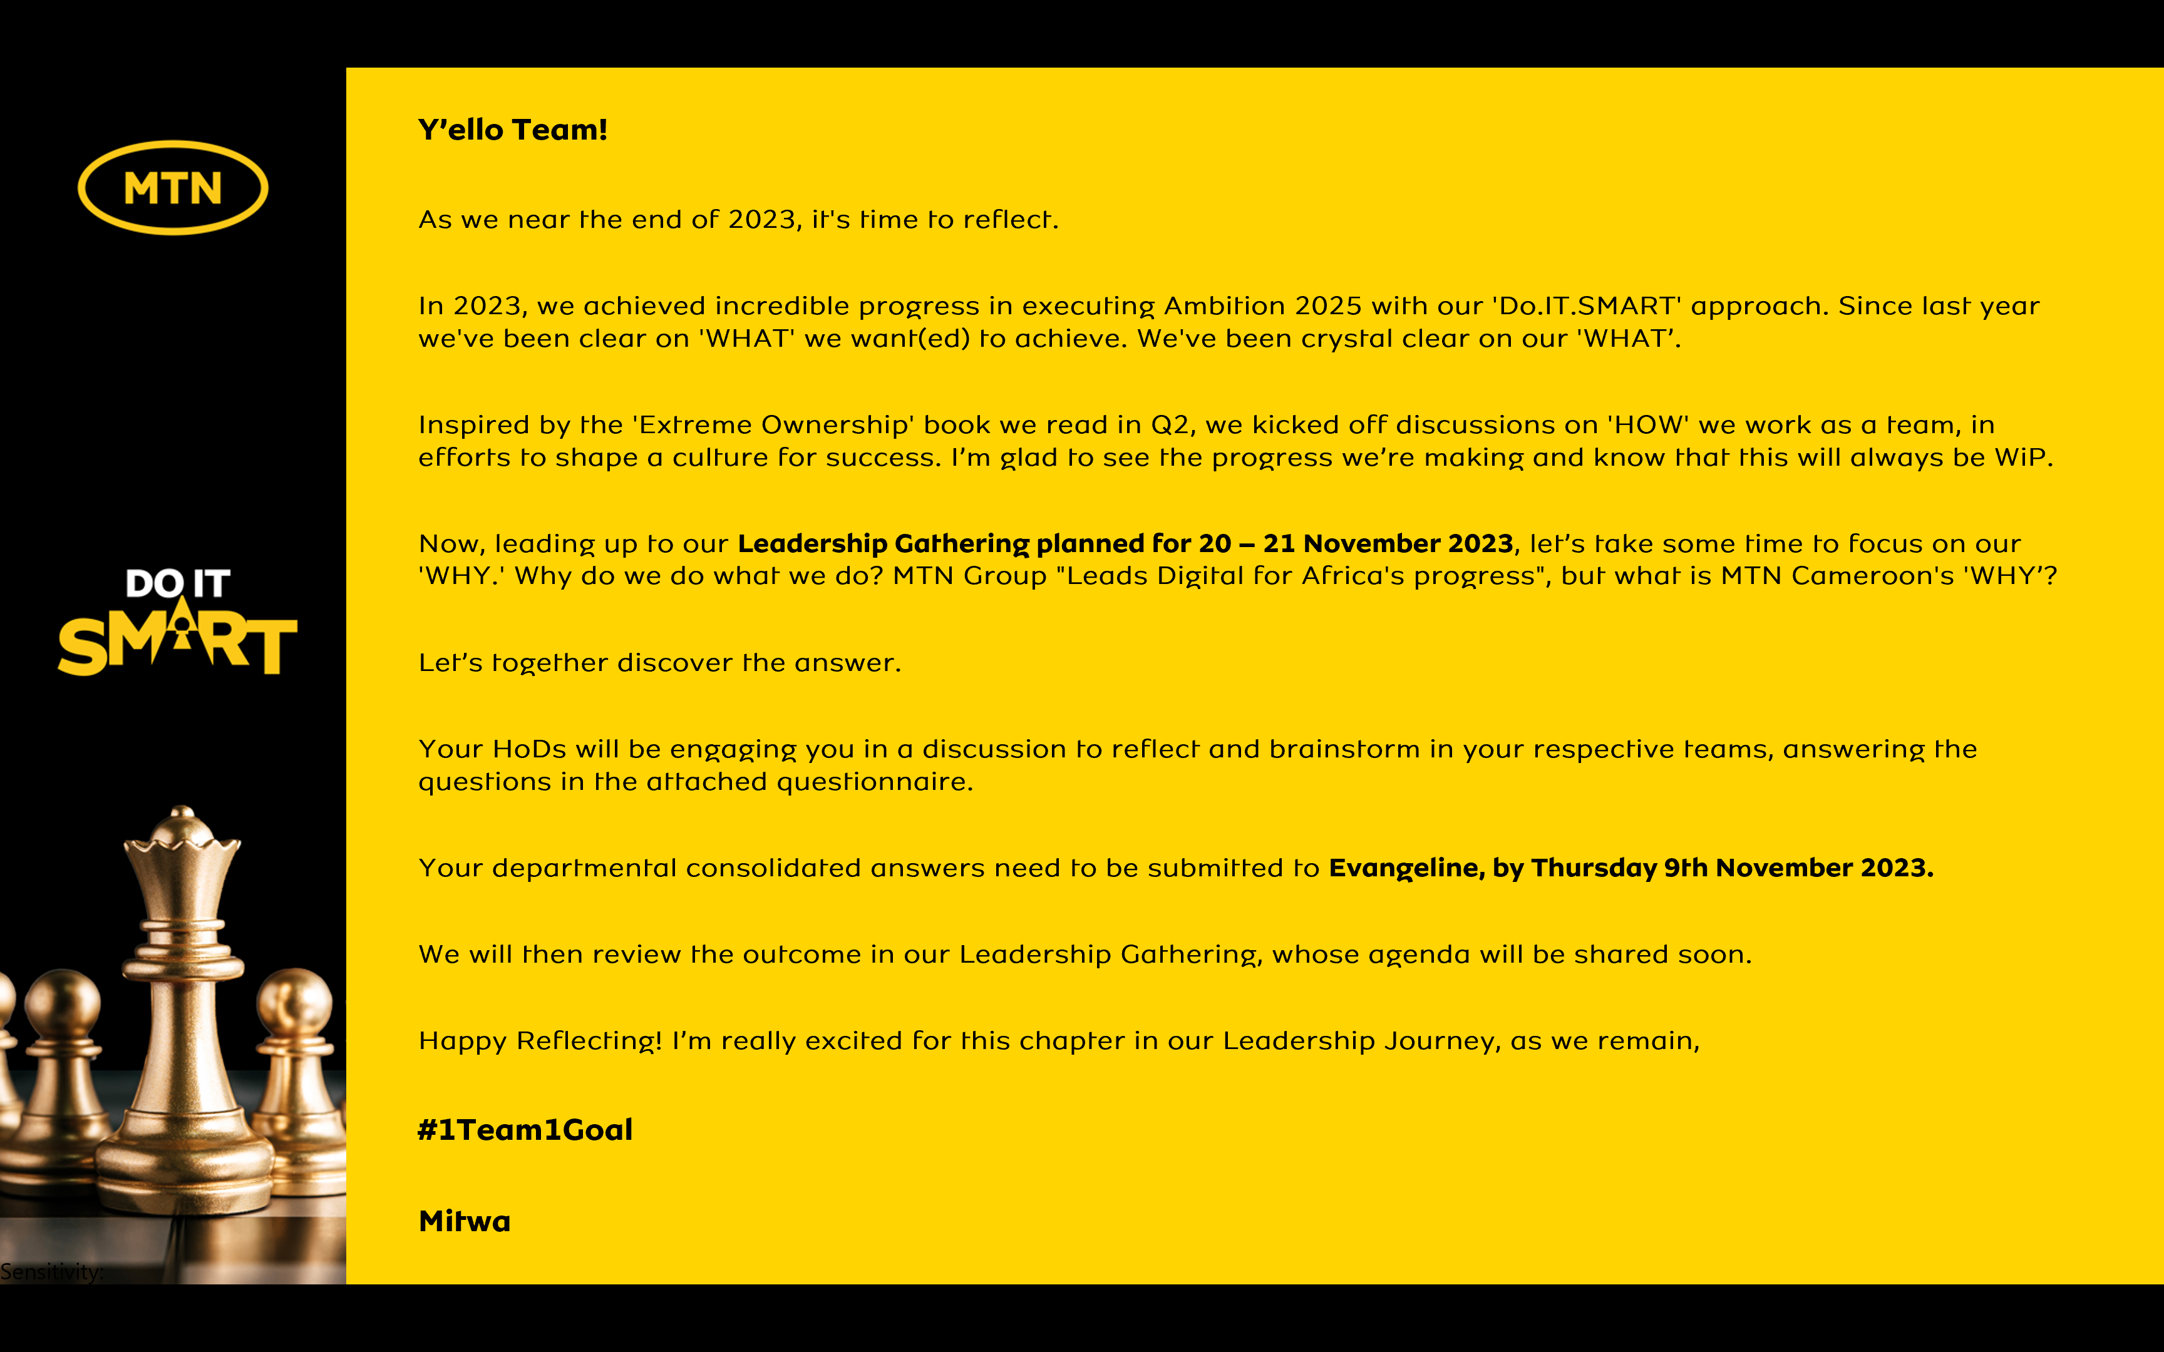
Reflecting on MTN Cameroon’s Purpose
1. When we look back as an organization, what have we always been good at? What are the 5 qualities that our organization has always had?
1- Brand
2- Innovation
3- CSR
4- People
5- Market Leadership
2. Looking back into our history of working together as an organization, what is the moment when you felt truly happy and what did we achieve?
21 Days of Yellow Care - Built and equipped a working space for people with disabilities
3. When we are collaborating as a leadership team under what circumstances do we have the most high performing energy?
When we are living our Vision and Values
4. What was the most challenging time in working together as a leadership team? What have we learnt from it?
Transformation (2018 -2019) - we learnt the importance of Accountability, Transparency, Resilience and Courage
5. What is the most important thing we want to accomplish as MTN Cameroon? What would we like to be known for when people talk about us in 5 years from now?
Transformation of Cameroonian lives through digitalization
6. There are no restrictions or limitations. The future is not known. In this moment we have the power to choose. What is our common vision going forward? What is possible when our organization puts together the best version of every individual member?
Every Cameroonian deserves a fast and reliable network, financial inclusion and a modern life

In summary,

MTN Cameroon’s Purpose in life is to

“Offrir les services qui transforment le quotidien des Camerounais”

<repeat> “ Offrir les services qui transforment le quotidien des Camerounais”

is what our life at MTN Cameroon is about.

