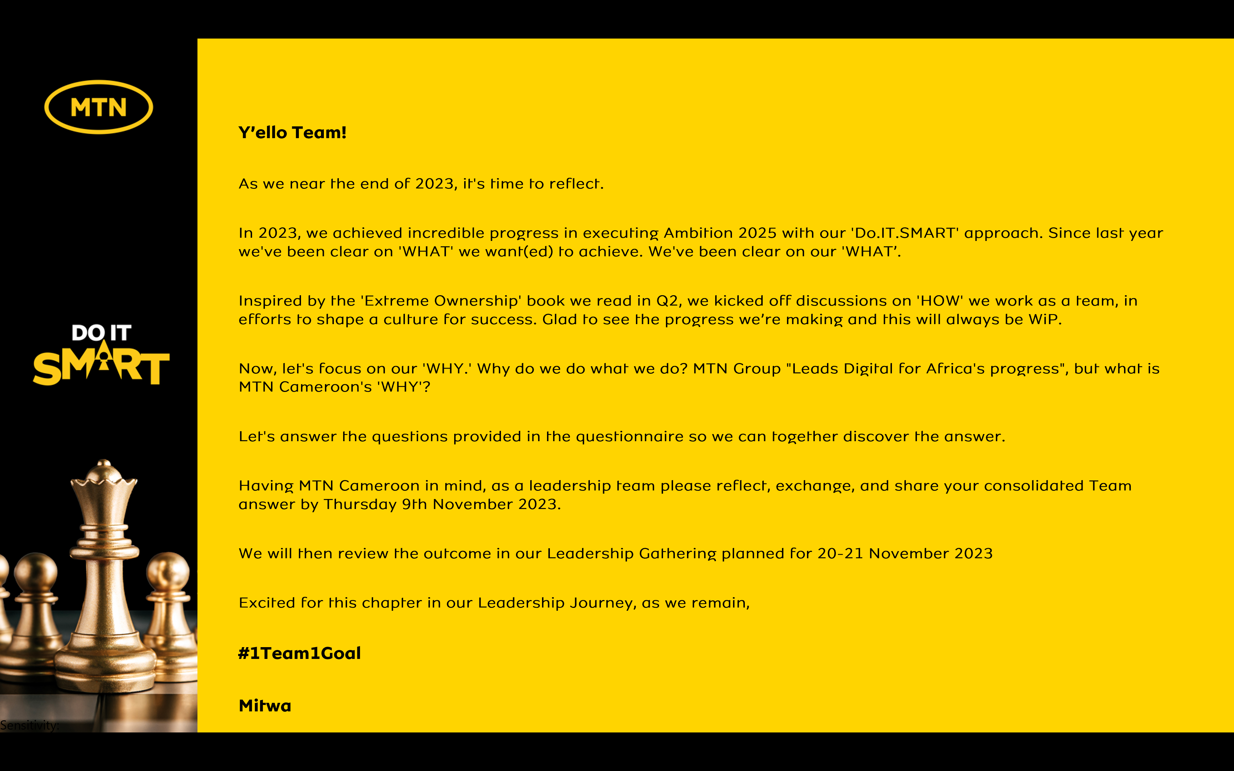

Reflecting on MTN Cameroon’s Purpose
1. When we look back as an organization, what have we always been good at? What are the 5 qualities that our organization has always had?
- High Profile Staffs
- Enterprise Culture: Performance Focus, Speed of Execution, Values, Trainings, Anti-Bribery Policy, Zero Tolerance to Non-Compliance Culture, Management openness, etc)
- Strong African Brand, Strong Affinity, etc
- Customer Experience, Relationship
- Advance Technology Pioneer & Leader: 4G launch, Home, MoMo, EVD, etc
2. Looking back into our history of working together as an organization, what is the moment when you felt truly happy and what did we achieve?
- 3G, 4G Launch: Innovation, being the 1st to launch in a very short period of time
- 1st NPS Leadership in 2018 after being no.3 and after cross functional efforts and togetherness
- Highest Performance Ever for MTN in 2022
- Tre mendous Bonus: 2014, 2015, 2020
- Big Market Events & Sponsorship: Sean Paul, PSquare & Passi+Kassav Devarieux Concerts, World Cup 2010: Official Sponsoring + Customer Participation to World Cup

3. When we are collaborating as a leadership team under what circumstances do we have the most high performing energy?
- Challenging circumstances
- Good Results, Performance, Praise & Recognition + Bonus & Rewards
- Leadership & Motivation: Participative & Collaborative, Strong but Fair, Performance Focus & Driven, Visionary, Rewarding, Rational and Non-Emotional,
- High Synergy between leaders: When sharing same goal and Silos are broken - Cross Functional Collaboration
- Specific Focused Targets: few & Simple objectives to reach

4. What was the most challenging time in working together as a leadership team? What have we learnt from it?
- Leadership Misalignment (few years back): When Leaders were fighting each other and were promoting silo work (involving their teams) – We eventually failed as a team: Company turned from high profits to loss. We learned to work collaboratively.
- Crisis Moments (2005): Mbanga Mpongo Crash – We adopted Continuity measures to minimize risks (separate travels for Executives, etc)
- Different & Conflicting Goals & Objectives (before 2019): We finally failed together – Shared KPIs has solved this issue
- Poor Performance leading to Finger Pointing (few years back): Learned to push for achievements and positively contribute together (via Crisis meetings / Marshall Plan, etc)
- Leadership Style: Emotional & Non-Rational, (everyone is accountable and plays its own role)
5. What is the most important thing we want to accomplish as MTN Cameroon? What would we like to be known for when people talk about us in 5 years from now?
- Best African Brand
- Best Brand Contribution to Cameroon development (FNE, Digital Economy, etc) and giving back to our communities: ESG, MTN Foundation, 21Days, etc
- Best Competent Staff - High Profile Staff
- Best Place to Work: Salary & Rewards & Well Being
- Best Reference for Customer Experience in Cameroon

6. There are no restrictions or limitations. The future is not known. In this moment we have the power to choose. What is our common vision going forward? What is possible when our organization puts together the best version of every individual member?
- Be the best reference at what we do
- Develop our Country and Give back to our communities
- Develop Local Competencies and Talents
- Be the preferred Operator (FinTech, Network, Digital, etc) for the Market (Customers & Partners)
- Provide the best CEX in Africa

In summary,

MTN Cameroon’s Purpose in life is to
“ELEVATE CAMEROON”

<repeat> “ELEVATE CAMEROON”

is what our life at MTN Cameroon is about.

