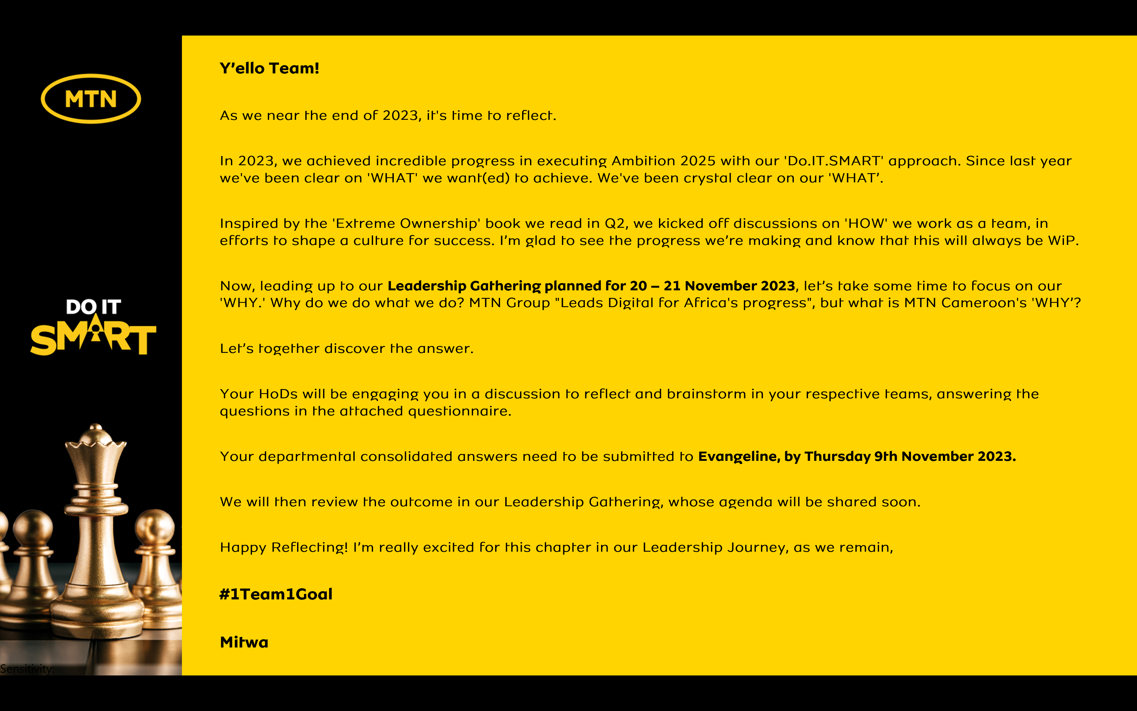

Reflecting on MTN Cameroon’s Purpose
1. When we look back as an organization, what have we always been good at? What are the 5 qualities that our organization has always had?
MTN Cameroon has always been good at the protection of its brand through various initiatives: IP protection, best customer experience at any touch points and actions in its community.

The qualities of our organisation have always included:

- Focus on its people: training programmes, recognition and reward scheme etc leading to sustainable dedication and engagement.;

- Strength of the brand: MTN ranked among best brands in Africa.

- Innovation: introducing new services on the market (EVD, Pay as yo Go etc.). Change of process for efficiency and cost reduction: Direct To Customer, Direct to Retail

- Strength of its values: integrity, compliance and ethics underpin all actions of MTNC

- Support from the Group: MTN is part of a strong Group that has always provided support to MTN Cameroon when required.

2. Looking back into our history of working together as an organization, what is the moment when you felt truly happy and what did we achieve?
The process of preparing and submitting the application for the PSP license
3. When we are collaborating as a leadership team under what circumstances do we have the most high performing energy?
When working under stress and on tight objectives with significant impact on the company image or position as leader

4. What was the most challenging time in working together as a leadership team? What have we learnt from it?
When working on complex legal matters.

- FINCO managed separation in 2022
- Launch of End of Year Promotions
- Litigation where accounts were attached and high risk of significant loss (Appstech, Bestinver)

From the above, we learnt tenacity (do not give up until you reach a solution), openness (listen to all suggestions), togetherness (breaking the silos and working in synergy for a common goal) and thoroughness (explore all possibilities and pay attention to details)

5. What is the most important thing we want to accomplish as MTN Cameroon? What would we like to be known for when people talk about us in 5 years from now?
We would like MTN Cameroon to be recognized as the leading contributor to the achievement by the State of Cameroon of its strategic objectives by leveraging on technology.

6. There are no restrictions or limitations. The future is not known. In this moment we have the power to choose. What is our common vision going forward? What is possible when our organization puts together the best version of every individual member?

Be the leading company in Cameroon in the field of technology and fintech. Make every citizen adopt technology and fintech as major tools for efficient resolution of daily problem.

In summary,

MTN Cameroon’s Purpose in life is to

“be the enabler of the achievement by Cameroon of its digital strategic objectives ”.

“be the enabler of the achievement by Cameroon of its digital strategic objectives”

is what our life at MTN Cameroon is about.

