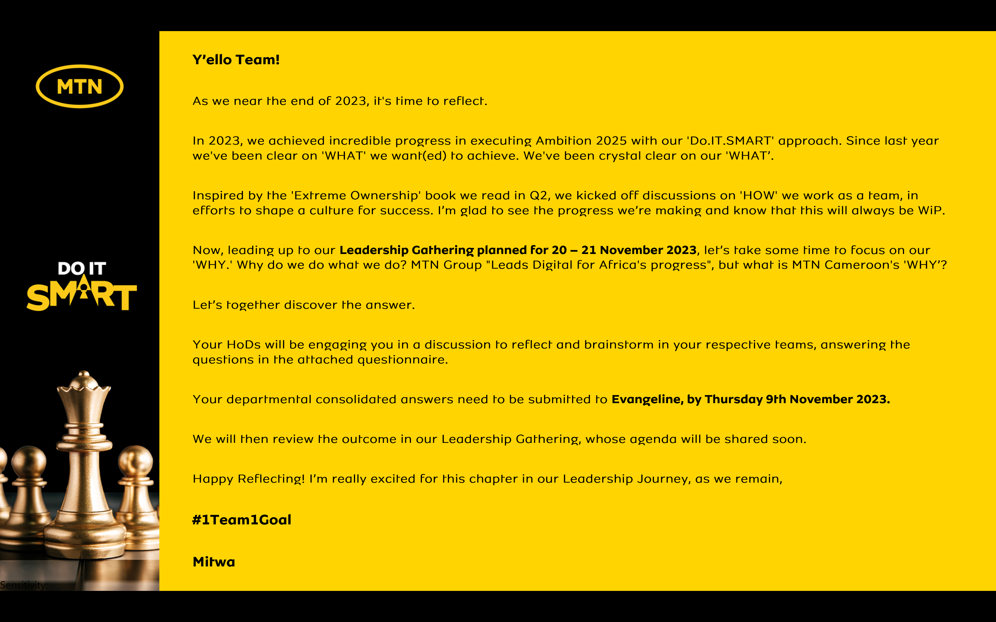

Reflecting on MTN Cameroon’s Purpose
1. When we look back as an organization, what have we always been good at? What are the 5 qualities that our organization has always had?
- Continuous Network Investment and improvement
- Innovation: Launch of products that have transformed the lives of Cameroonians e.g Me2U
- Leadership Culture & People Focus:
- Empowering people to take decisions without input from Top Management
- Social impact and the role we play in society.
  - Governance: MTN has a good and very strong BOD that provides oversight.
  - Quality workforce.
  - Good Channel Management: Strong Distribution network
- Go to Market
- Products & Services
- Campaigns

2. Looking back into our history of working together as an organization, what is the moment when you felt truly happy and what did we achieve?
The Social Impact we have made:
- Personalized birthday messages sent by the CEO to staff.
- Consistency of 21 Days Yello Care
- Inclusive Culture

3. When we are collaborating as a leadership team under what circumstances do we have the most high performing energy?
- When Leaders find a middle ground during discussions
- When purpose is understood: People often do not execute because they do not understand their roles and the purpose of the organisation

4. What was the most challenging time in working together as a leadership team? What have we learnt from it?
- COVID 19 Pandemic: There was no visibility on the way forward, the future was cloudy and thus leaders had to exert a lot of energy. There were people challenges amidst trying to meet business objectives.
The lesson here was that at challenging times leaders stick together.

- MMC/MTNC Split: No clarity of purpose and understanding of Group’s directives.
The lesson here is that when the purpose of something is not properly clarified, the ability to work together as leadership is a challenge.

5. What is the most important thing we want to accomplish as MTN Cameroon? What would we like to be known for when people talk about us in 5 years from now?
- MTN Cameroon should be top of mind in providing sustainable value to our customers, stakeholders, and the community at large.
- We would like to be known as the leadership team that changed positively the narrative of MTN Cameroon.

6. There are no restrictions or limitations. The future is not known. In this moment we have the power to choose. What is our common vision going forward? What is possible when our organization puts together the best version of every individual member?
- MTN’s Vision should be to drive everyone to sustainable continuous access to the highest quality of goods and services.
- When our organization puts together the best version of every individual member the sky will be the limit

In summary,

MTN Cameroon’s Purpose in life is to

“...Deliver sustainable continuous digital access; be at the forefront of ensuring an inclusive and an ethical society and embark on supporting our community …”

“...Deliver sustainable continuous digital access; be at the forefront of ensuring an inclusive and an ethical society and embark on supporting our community …”

is what our life at MTN Cameroon is about.

