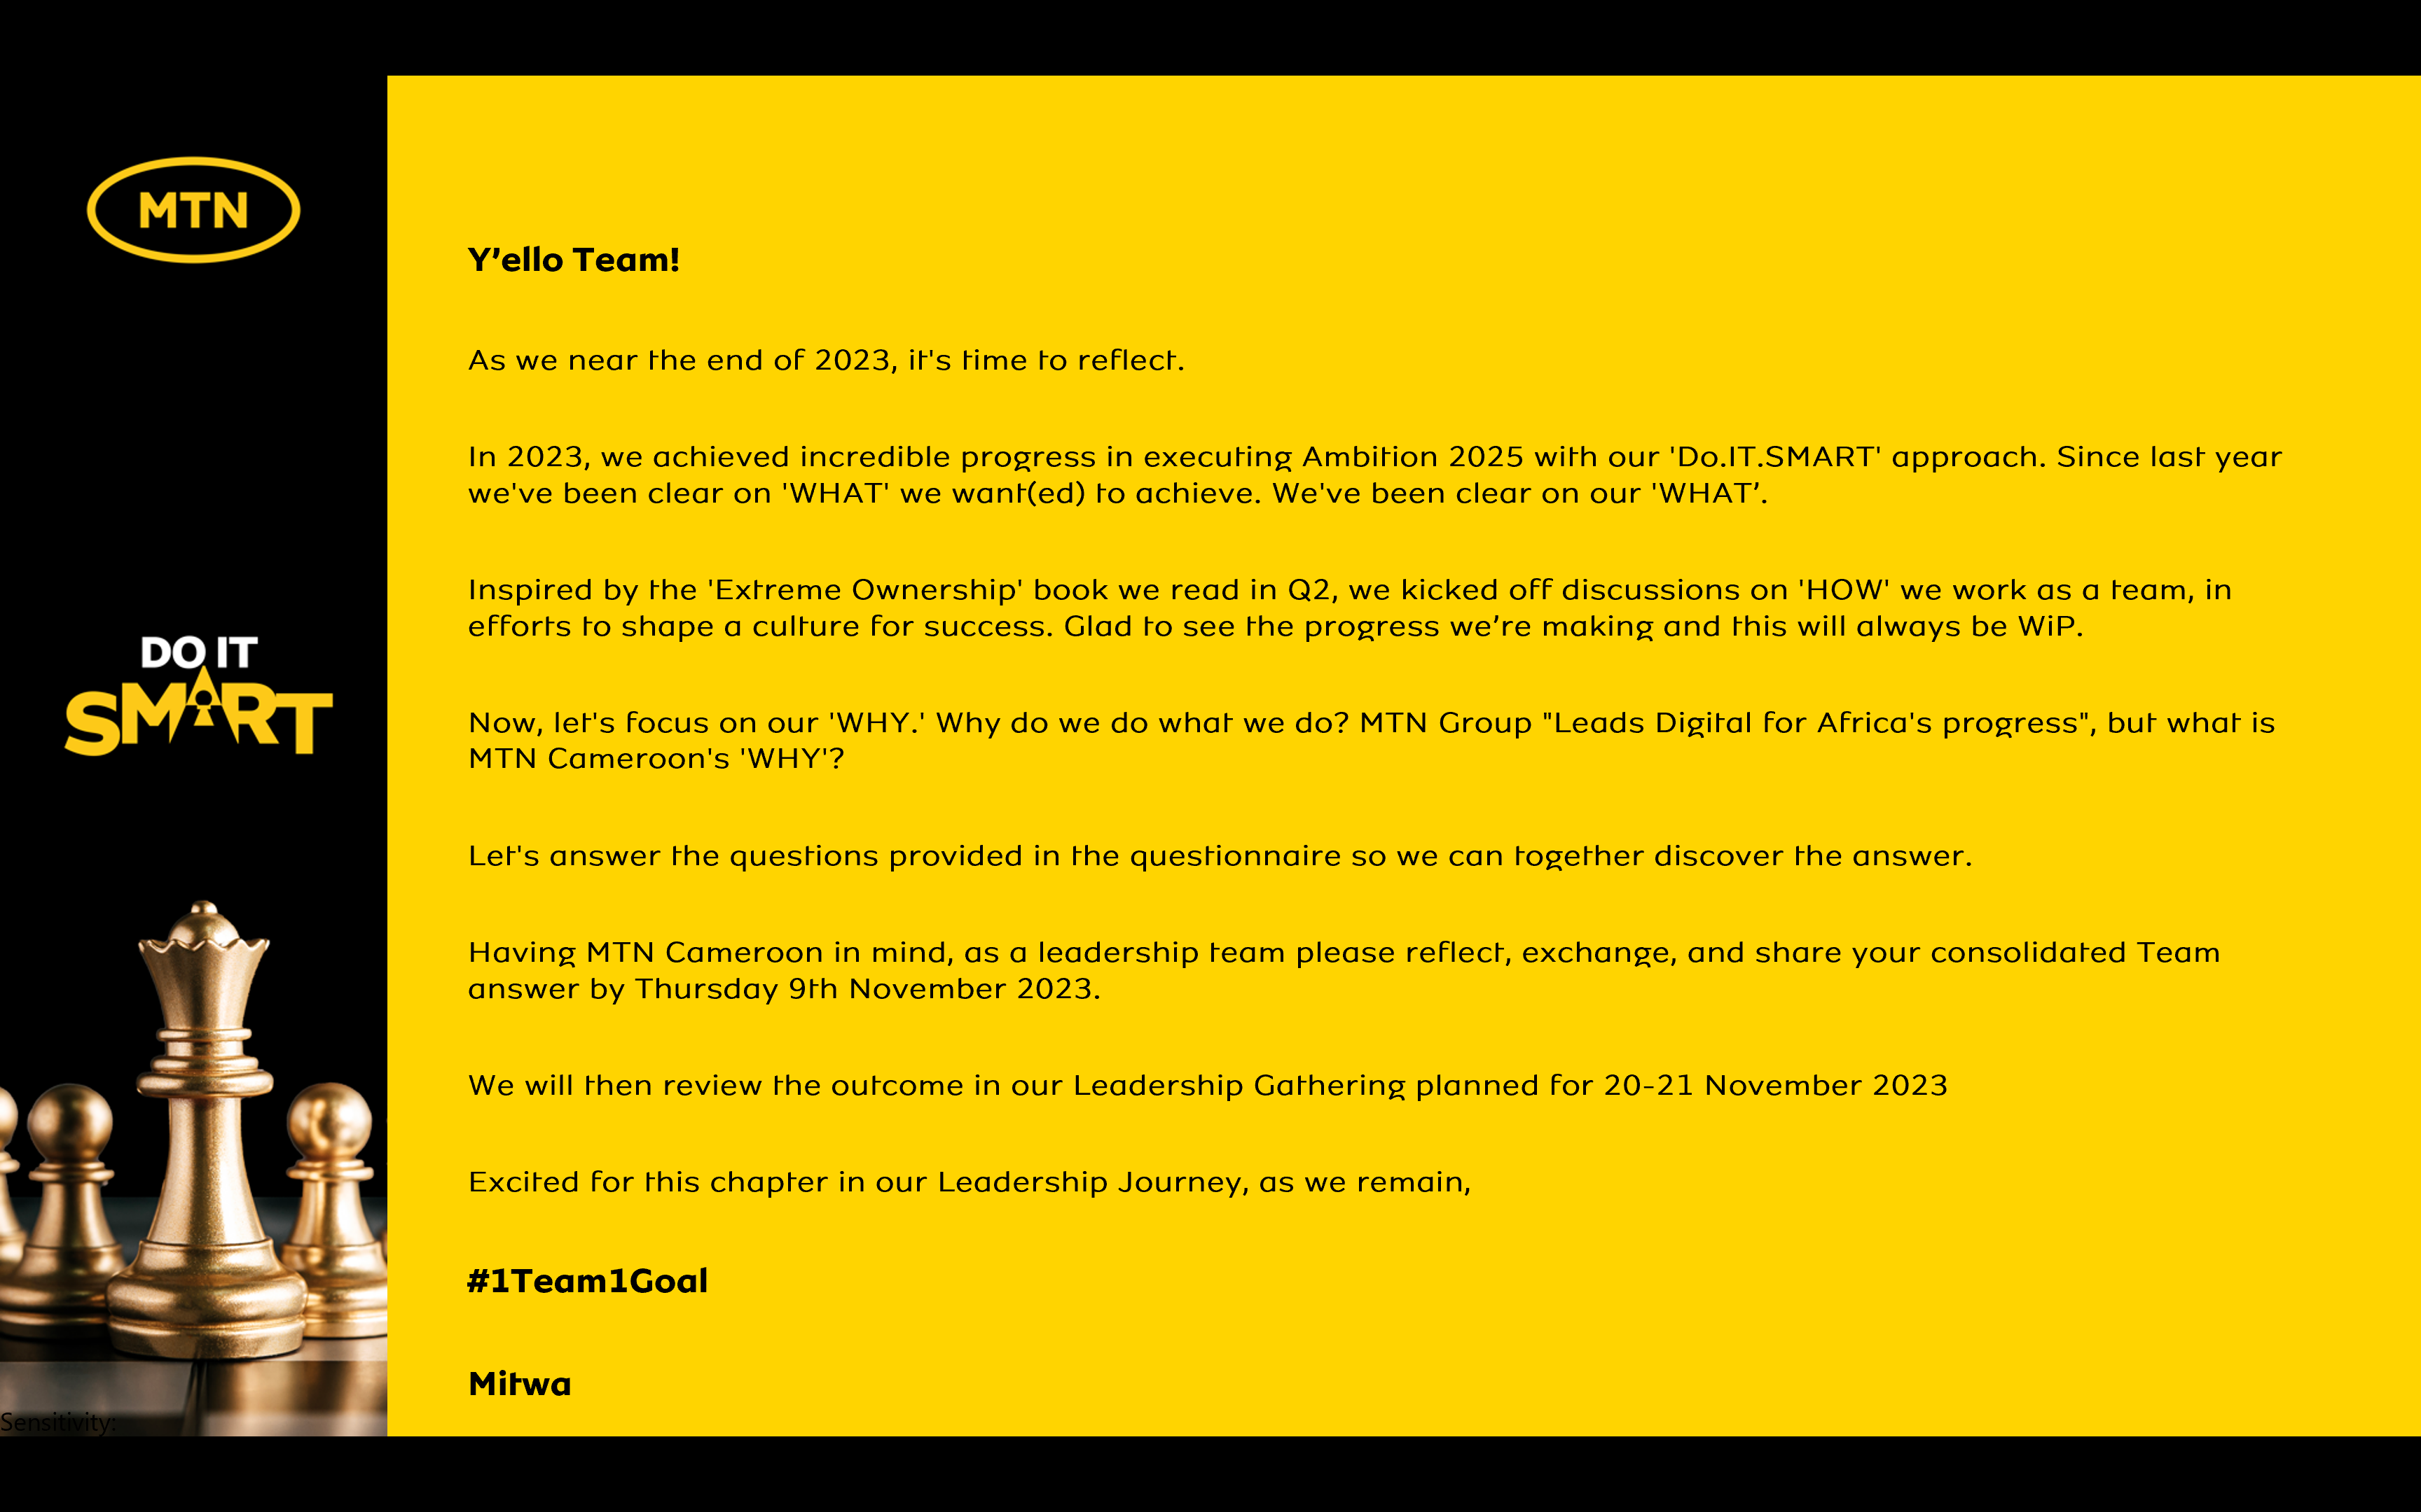

Reflecting on MTN Cameroon’s Purpose
1. When we look back as an organization, what have we always been good at? What are the 5 qualities that our organization has always had?
1- Devoted:
2- Innovation:
3- Resilience:
4- Talented:
5- Engaged:

2. Looking back into our history of working together as an organization, what is the moment when you felt truly happy and what did we achieve?
- Ambush Campaign AFCON 2021
- Unbeatable Campaign with Ngannou,Rigo, Abouchou
- Launch of 4G Network (1st Operator in Cameroon)
- Launch of the End of Year Campaign MTN Rush

3. When we are collaborating as a leadership team under what circumstances do we have the most high performing energy?
- When we have to defend our leadership position in the market

4. What was the most challenging time in working together as a leadership team? What have we learnt from it?
Most challenging time:
- Covid 19 Period, 2020 - 2023
Learn
- Lead with Care, Agility, resource optimisation, Put the human at the center

5. What is the most important thing we want to accomplish as MTN Cameroon? What would we like to be known for when people talk about us in 5 years from now?
- Put a smartphone on a hand of every Cameroonian.

- Democratize digital access in Cameroon.

6. There are no restrictions or limitations. The future is not known. In this moment we have the power to choose. What is our common vision going forward? What is possible when our organization puts together the best version of every individual member?
Vision: Thrive
Nothing is impossible for Cameroonian, We can achieve above expectation.

In summary,

MTN Cameroon’s Purpose in life is to

“……… WIN as One………”

<repeat> “ ……… WIN as One ………”

is what our life at MTN Cameroon is about.

