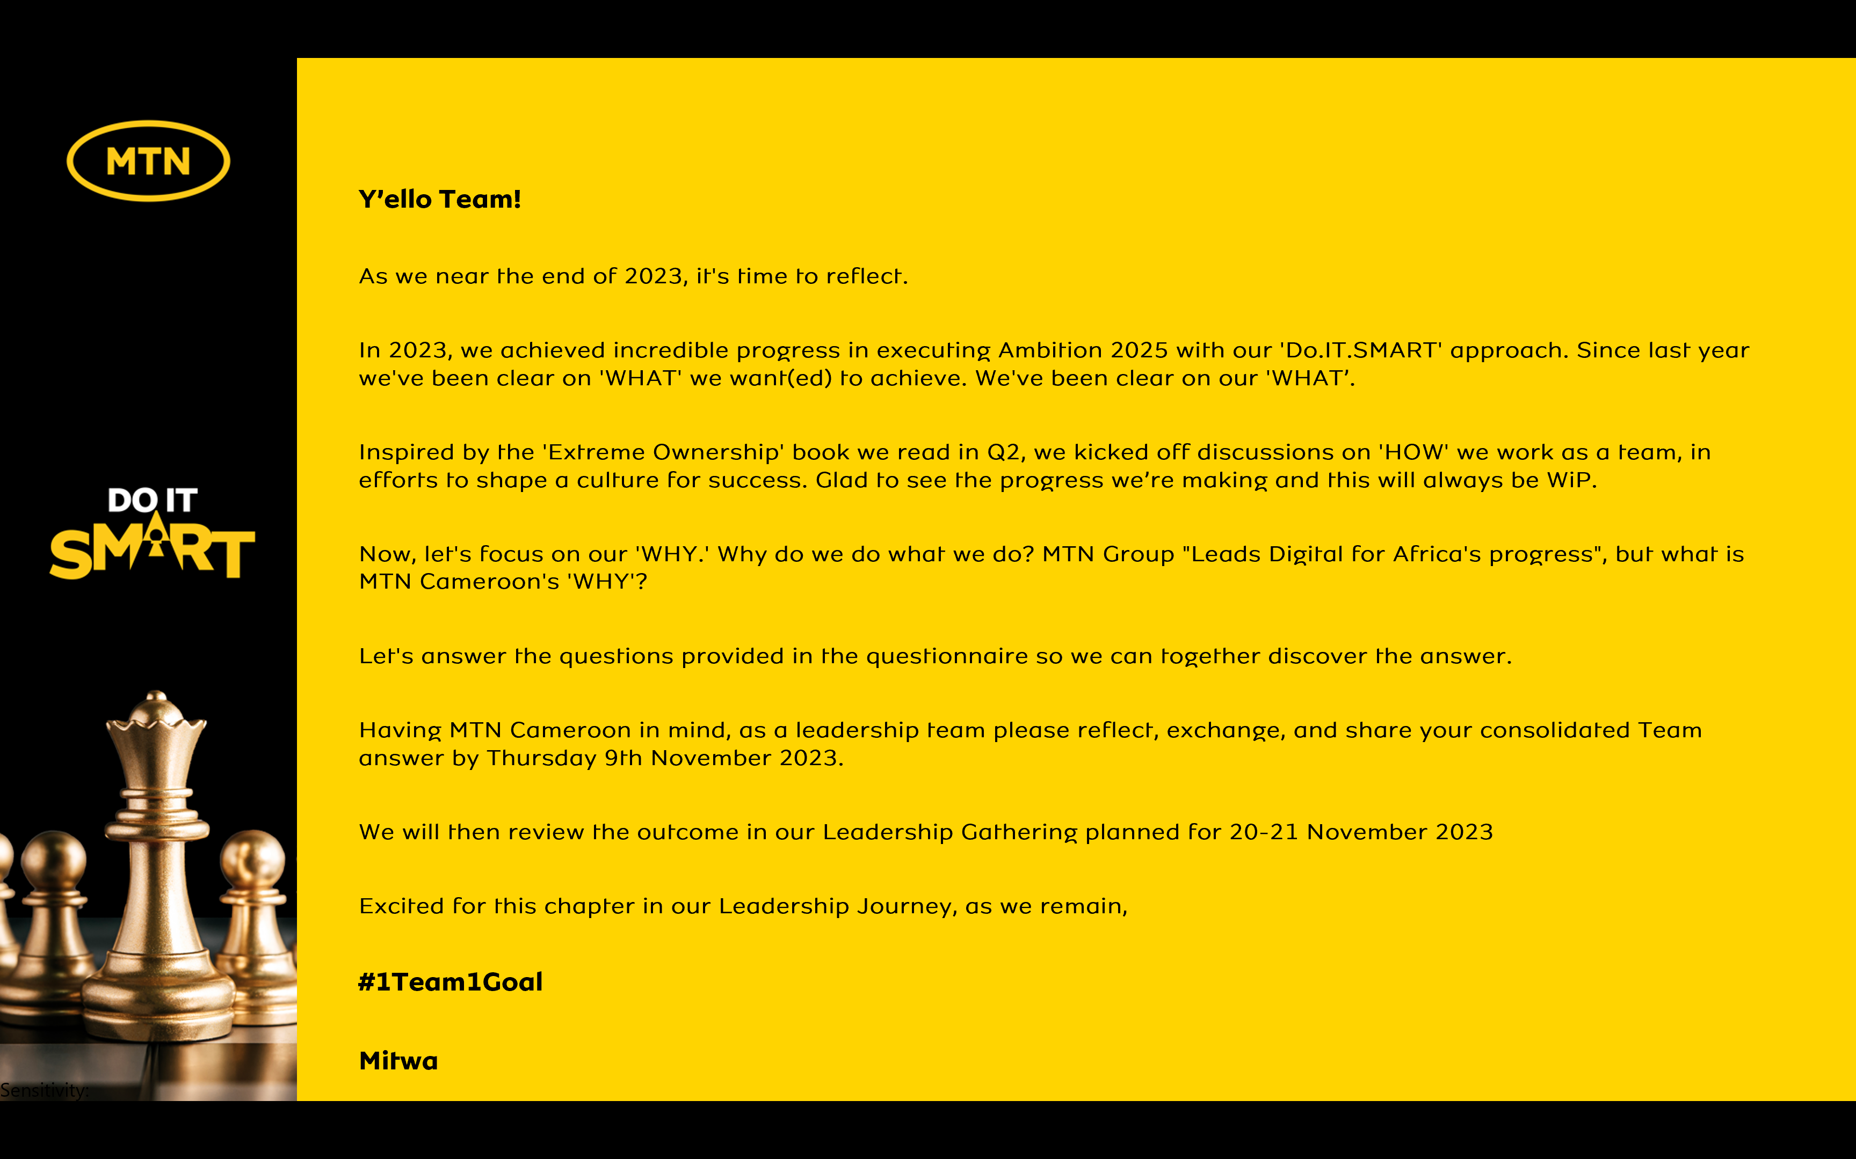

Reflecting on MTN Cameroon’s Purpose
1. When we look back as an organization, what have we always been good at? What are the 5 qualities that our organization has always had?
- Stability in the market- Market leadership
- Positive and inspiring company culture
- Brand strength
- Sustainable Relationships
- Reputation

2. Looking back into our history of working together as an organization, what is the moment when you felt truly happy and what did we achieve?
Results publication - Market share and NPS achievements

3. When we are collaborating as a leadership team under what circumstances do we have the most high performing energy?
- Brand/ Competition challenges
- Crisis management

4. What was the most challenging time in working together as a leadership team? What have we learnt from it?
Priorities and KPIs alignment. Real implementation of 1 team 1 goal motto.

5. What is the most important thing we want to accomplish as MTN Cameroon? What would we like to be known for when people talk about us in 5 years from now?
Connect the unconnected
Corporate social responsibility

6. There are no restrictions or limitations. The future is not known. In this moment we have the power to choose. What is our common vision going forward? What is possible when our organization puts together the best version of every individual member?
Drive digital access and solutions in Cameroon

In summary,

MTN Cameroon’s Purpose in life is to

“Provide Inclusive digital access to each Cameroonian”

“Provide Inclusive digital access to each Cameroonian”

is what our life at MTN Cameroon is about.

