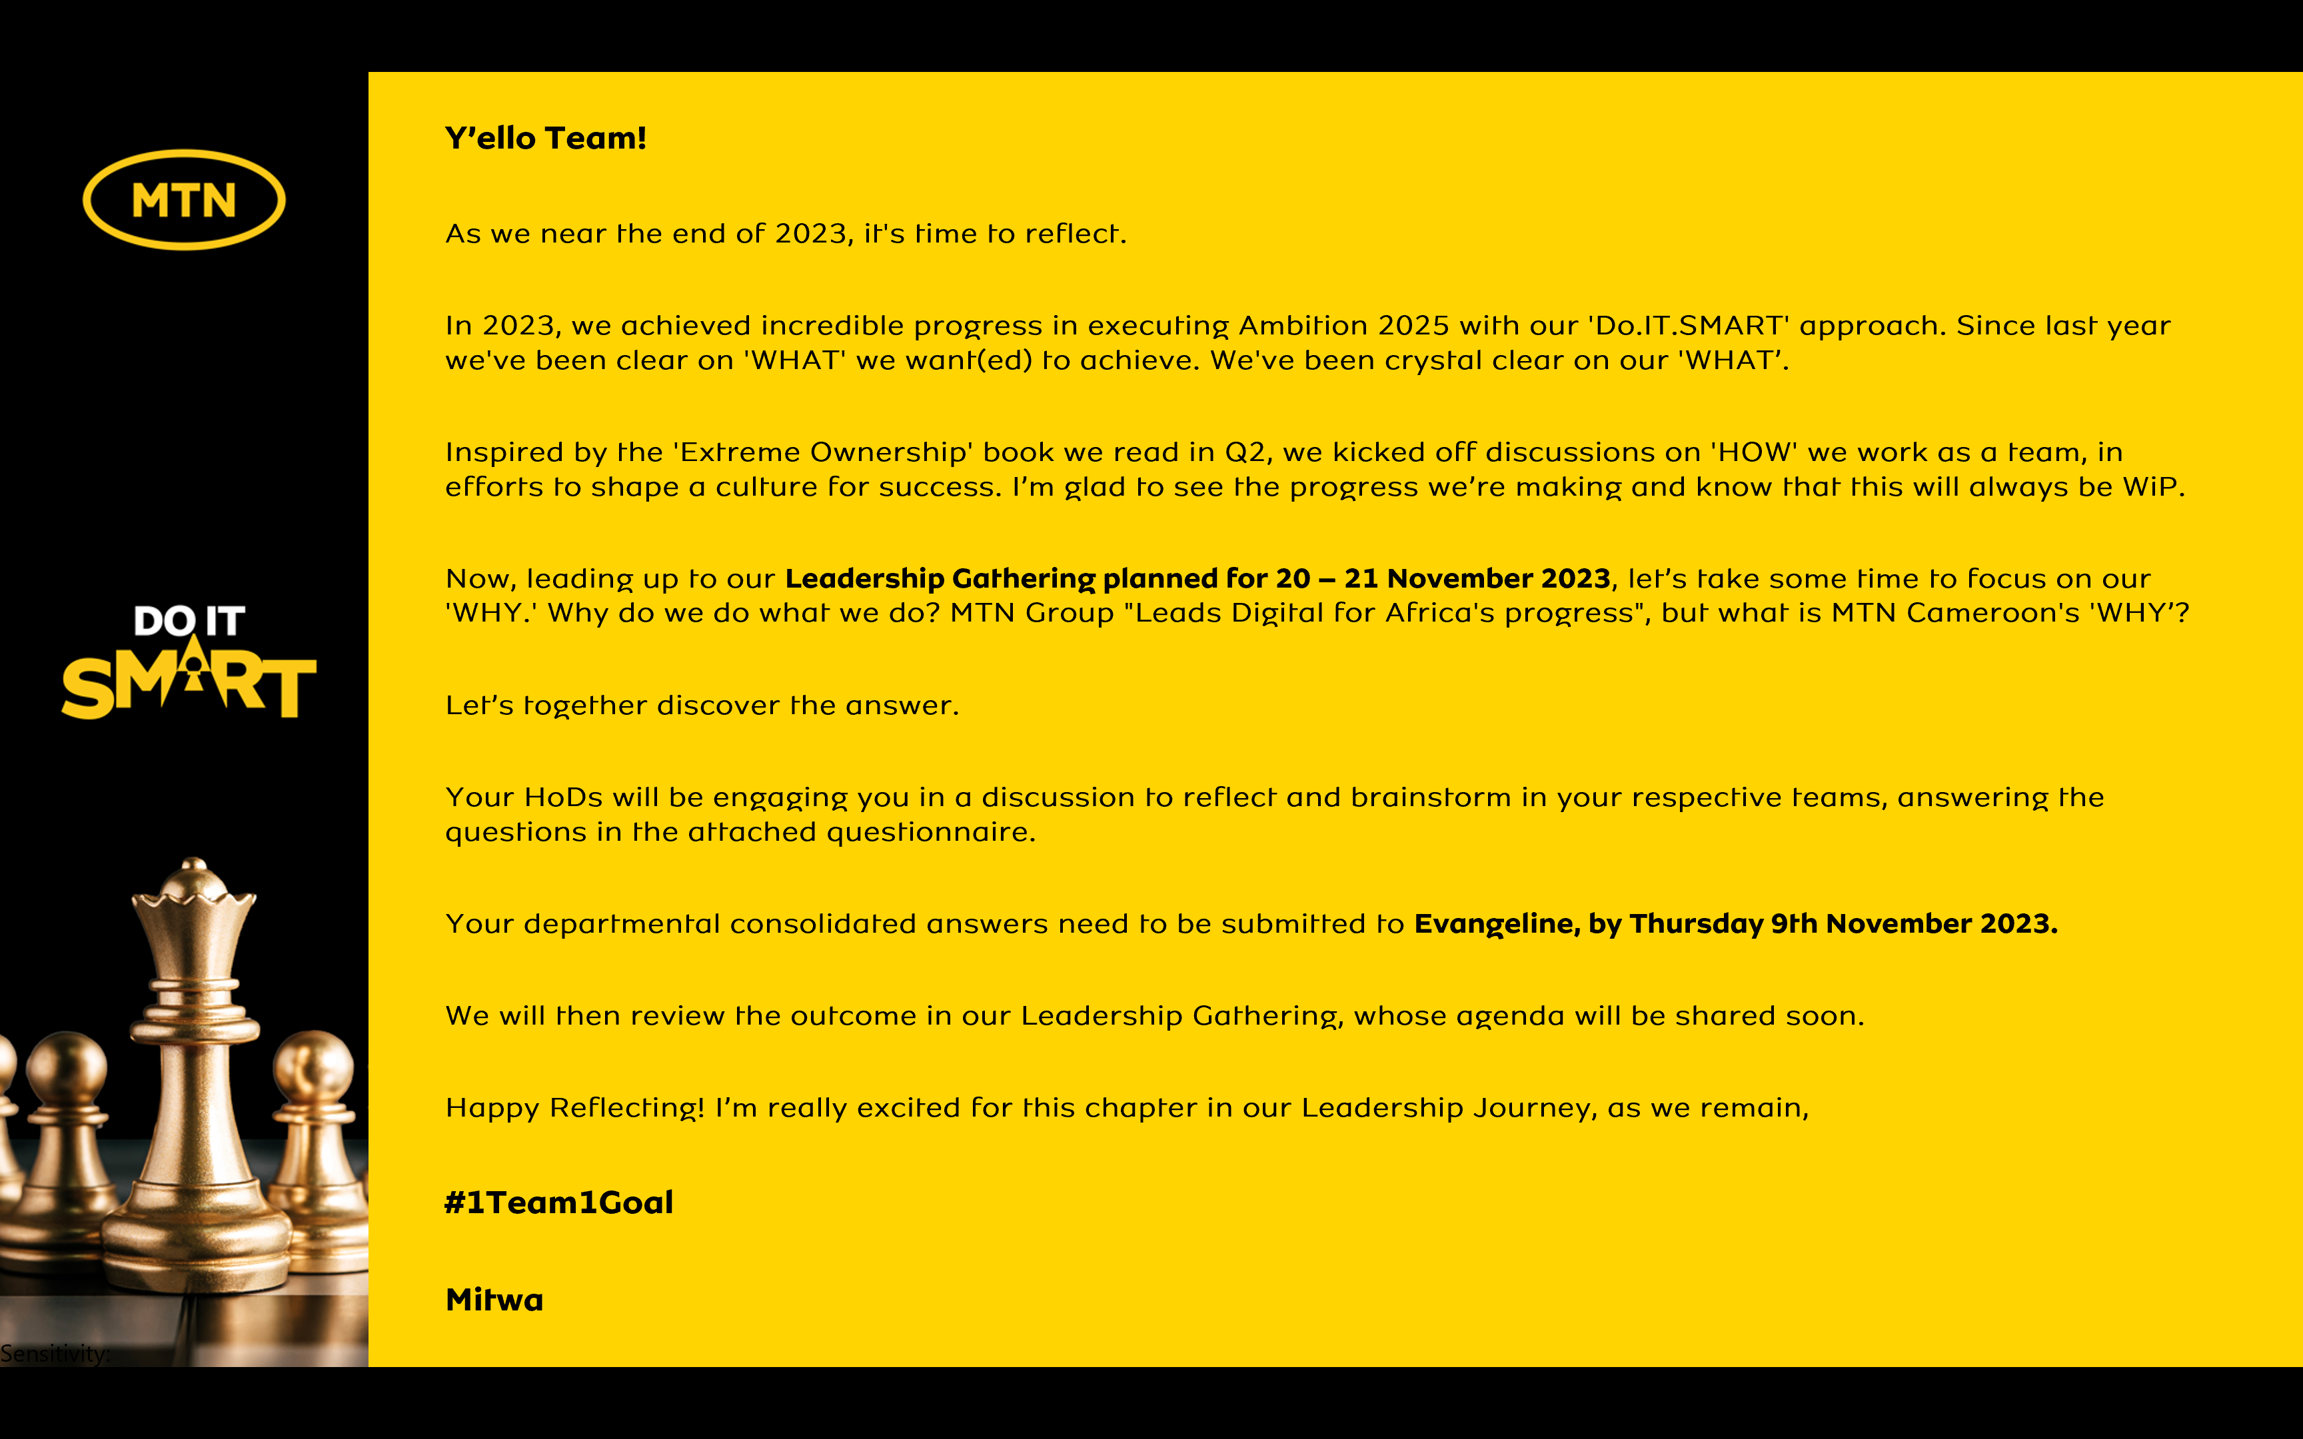

Reflecting on MTN Cameroon’s Purpose
1. When we look back as an organization, what have we always been good at? What are the 5 qualities that our organization has always had?
- Brand image/perception in every dimension
- Customer service & experience (NPS, Network QoE & coverage)
- Market proximity (footprint edge, omnichannel approach)
- Agility & Resilience
- Dynamic & committed team, fully accountability and responsible, result focus

2. Looking back into our history of working together as an organization, what is the moment when you felt truly happy and what did we achieve?
MoMo transformational Mandate accomplishment

Achievements:
- Full shift from traditional EVD to embed MoMo at core
- MoMo pay growth (Value scaling)
- MFS Ecosystem enhancement
- Efficiency : CoS improvement, improved CX

3. When we are collaborating as a leadership team under what circumstances do we have the most high performing energy?
- Clear definition of the vision & mission,
- Shared goals & objectives that will determine success
- Agility room for change, adjustment to fit context
- Active collaboration & engagement of all stakeholders
- Extreme ownership mindset (Bottom top)

4. What was the most challenging time in working together as a leadership team? What have we learnt from it?
GAMEOVER launch Defining a clear scope & responsibilities within commercial team

Key Learnings
- Pre-alignment on goals (what success will look like)
- Clear definition and agreement on responsibility matrix
- Proper budget allocation for critical projects
- Necessity for radical Mindset shift from own (department) to privilege company interest

5. What is the most important thing we want to accomplish as MTN Cameroon? What would we like to be known for when people talk about us in 5 years from now?
“Unbeatable leadership in both GSM/financial service business”

5 years talk:
- Pacesetters in the digital transformation of Cameroon’s economy with simplified and life impacting solutions (Ayoba, aYo etc)

6. There are no restrictions or limitations. The future is not known. In this moment we have the power to choose. What is our common vision going forward? What is possible when our organization puts together the best version of every individual member?
a. Preferred digital solution provider in Cameroon

b. We become ;
- UNSTOPPABLE – Move mountains
- UNIQUE & COMPETITIVE,
- UNLOCK VALUES
- SUSTAINABLE GROWTH
- FLAWLESS EXECUTION

In summary,

MTN Cameroon’s Purpose in life is to

< KEEP CUSTOMERS CONNECTED TO WHAT MATTERS TO THEM WITH PASSION>

<repeat> “ KEEP CUSTOMERS CONNECTED TO WHAT MATTERS TO THEM WITH PASSION”

is what our life at MTN Cameroon is about.

