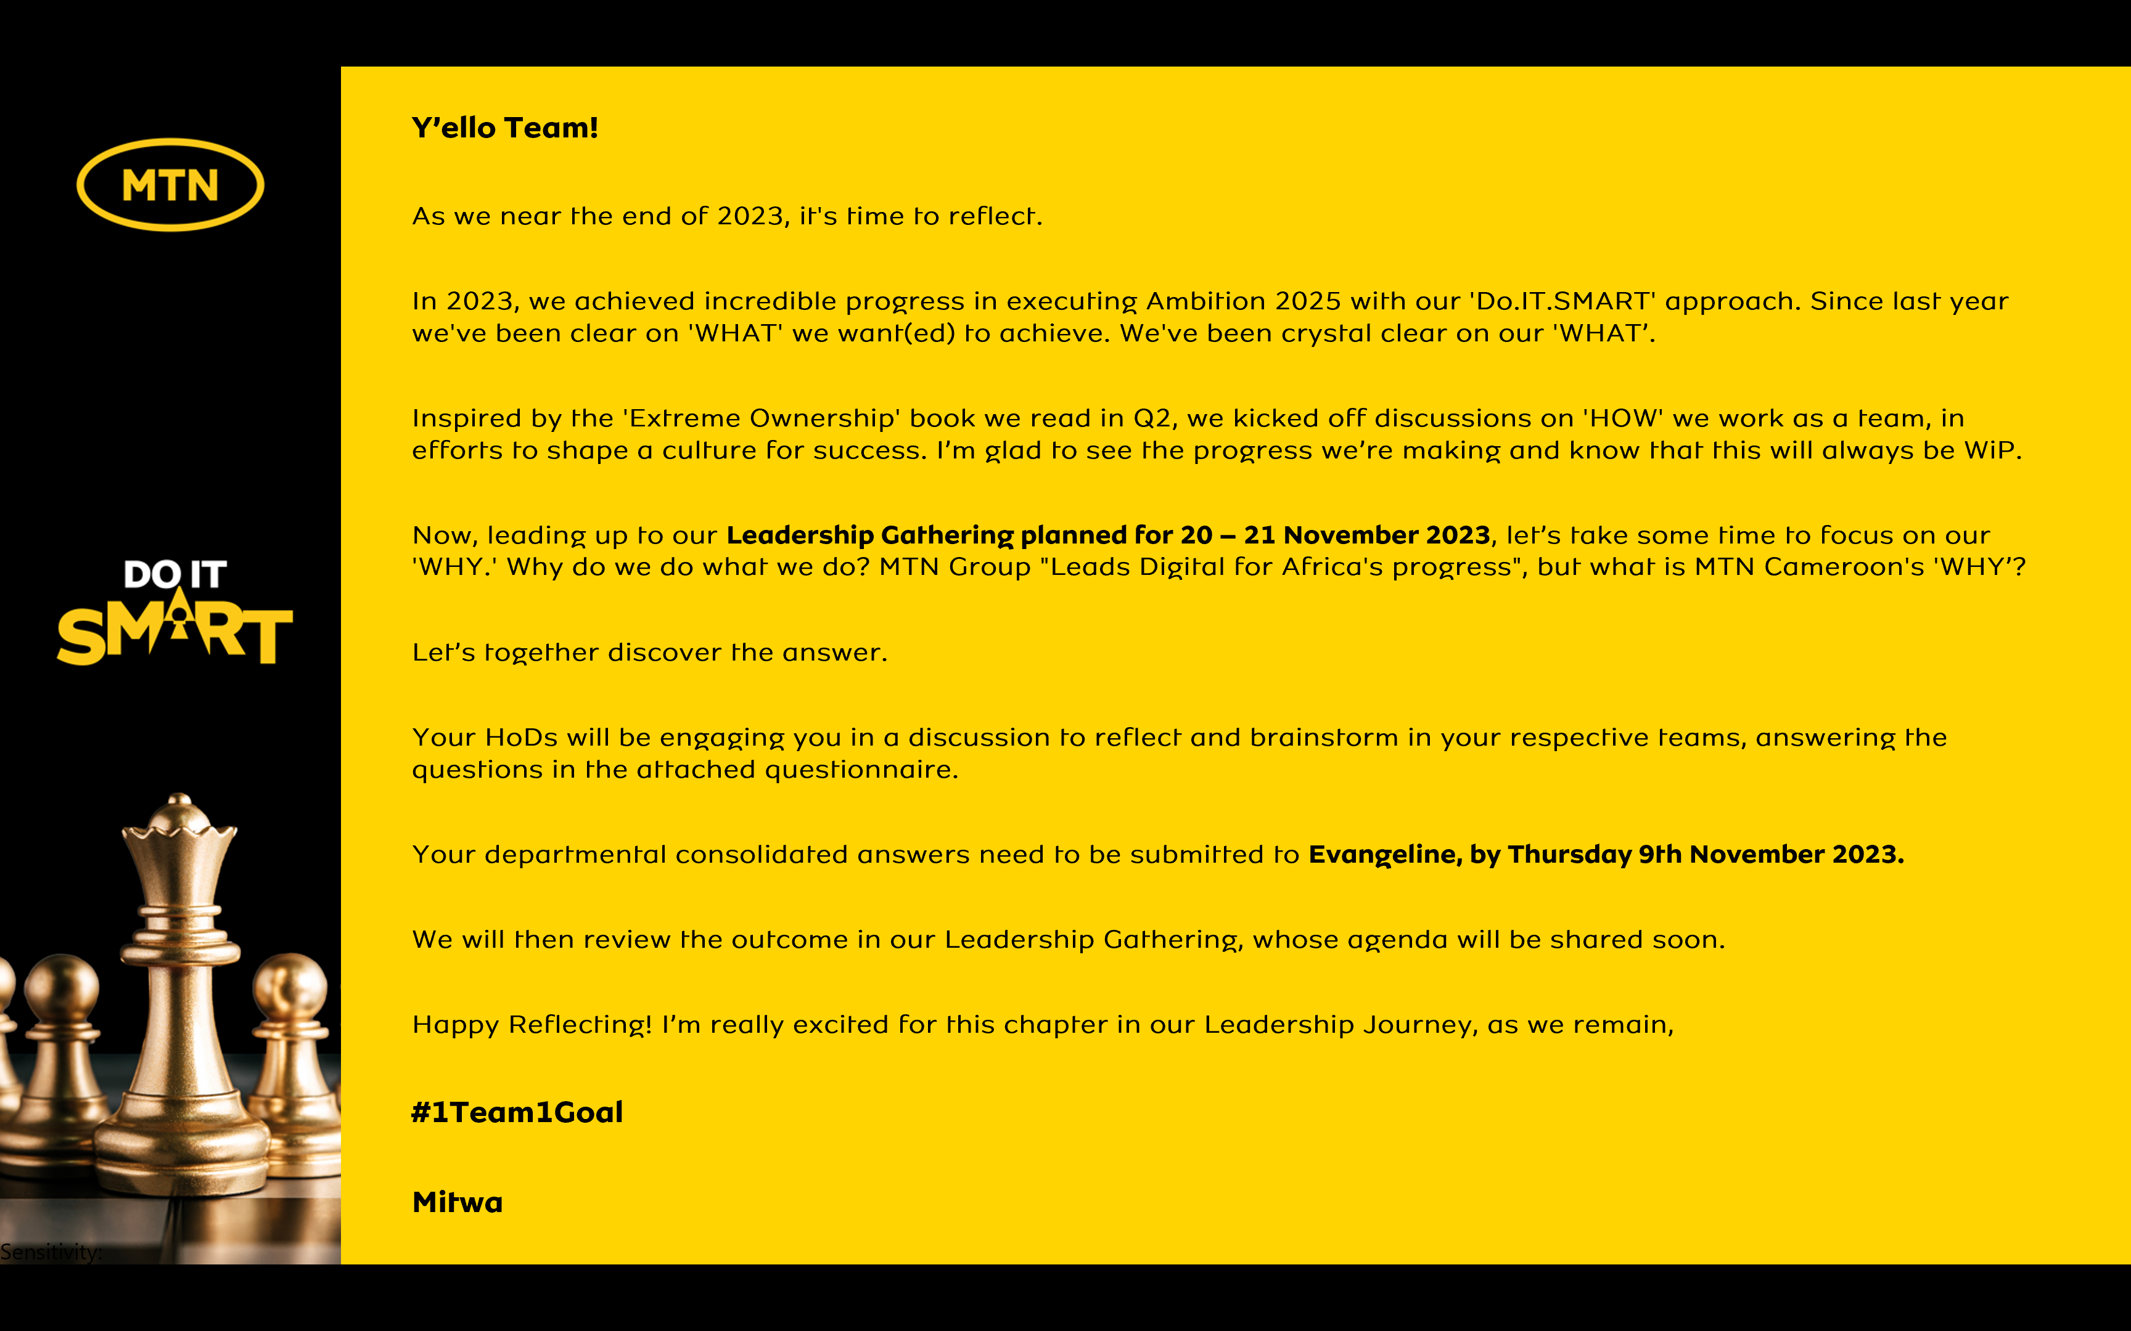

Reflecting on MTN Cameroon’s Purpose
1. When we look back as an organization, what have we always been good at? What are the 5 qualities that our organization has always had?
- Brand positioning
- Innovative products
- Talent recruitment
- Corporate Social Responsibility
- Competitiveness strength

2. Looking back into our history of working together as an organization, what is the moment when you felt truly happy and what did we achieve?
- MKT campaign: Immeuble de la mort, Sean paul concert, Villa campaign, Promote, World Cup 2010, etc.
- Yello Care : Career Day
- Impacting lives : Mintransport project, etc.

3. When we are collaborating as a leadership team under what circumstances do we have the most high performing energy?
- EBU is always high in terms of energy
- MIT events on the field cross functional
- 21 days of Yello Care activities

4. What was the most challenging time in working together as a leadership team? What have we learnt from it?
- 2017 / 2018
- Money is KING, capitalism
- Nul n’est indispensable
5. What is the most important thing we want to accomplish as MTN Cameroon? What would we like to be known for when people talk about us in 5 years from now?
- Impacting lives of Cameroon
- SMEs grown to be big enterprises Africa level
- MTN seen as the best enabler
- Changed as Digital Economy

6. There are no restrictions or limitations. The future is not known. In this moment we have the power to choose. What is our common vision going forward? What is possible when our organization puts together the best version of every individual member?
Impacting lives and Digital Economy in Cameroon

Moteur du developpement

In summary,

MTN Cameroon’s Purpose in life is to

“Impacting Lives”

<repeat> “ Impacting Lives”

is what our life at MTN Cameroon is about.

